- Can you briefly explain what WHS risks you identified at WALLETX during your assessment?
I found several risks. Firstly, there is no security guard at the entrance of the building. Unauthorized people can enter, which puts staff and building safety at risk.
I also mention the lack of exit signs, and the fire escape plan is almost falling off the wall. The emergency stairwell is blocked with security tape and barriers, and the lock is flimsy. This is very dangerous in case of a fire.
Inside the office, there are many trip hazards. Power cords, folders, and other items are scattered on the floor, especially on the footpath, which could cause someone to trip and fall.
The kitchen also has a serious issue: the power points are located directly above the sink, which creates an electrical risk.
In the storage room, I saw a leaking pipe and no lighting. It’s very hard to see in there, which could lead to slips, trips, or injuries.
In the Meeting Room 4, a staff member fell off a broken chair. According to the tour guide, she had fallen multiple times before, showing that the issue was not fixed. This reflects poor maintenance and a lack of care for employee safety.
These issues show that WALLETX needs to take WHS more seriously and improve its safety procedures.
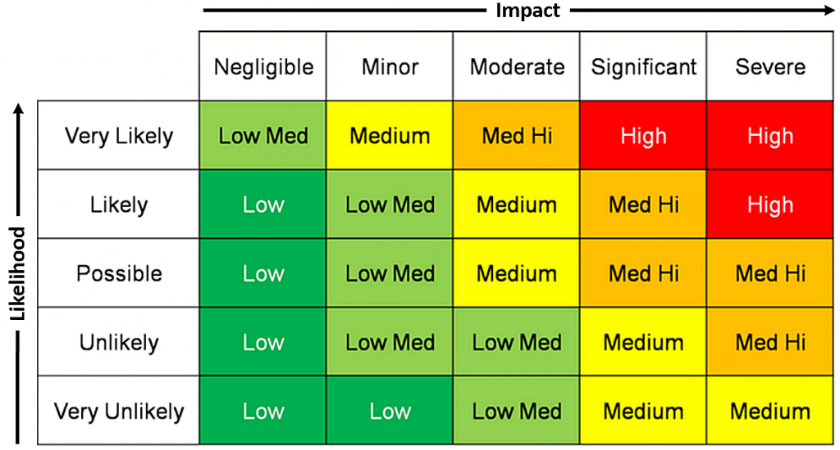
- What risk control measures would you suggest for these WHS issues?
- How would you rate the risk of someone getting injured because of the loose power cords — low, medium, or high? And why?
- What WHS regulation or standard can you refer to when making these recommendations?
- Was there any situation in the WALLETX office where someone already had an accident?
- If an employee falls at work and gets injured because of a known WHS hazard, what responsibilities does the company have under WHS law?
- What steps would you take to assess a WHS risk at WALLETX? Can you explain your risk assessment process?
- In your opinion, what is the most urgent WHS issue in WALLETX, and why?
- What communication protocol can your team use to report WHS risks?
- If your teammate ignores a WHS rule, how would you handle that situation?
2. What risk control measures would you suggest for these WHS issues?
Install a security guard or access control system at the entrance. Replace or reattach the fire escape plan properly and unblock the stairwell. Repair the lock. Tidy up the floor and organize cables using cable covers. Move kitchen power points away from the sink. Fix the leak in the storage room and install lighting. Replace all broken furniture, especially chairs in the meeting room 4. Regular safety checks and maintenance should also be scheduled.

3. How would you rate the risk of someone getting injured because of the loose power cords — low, medium, or high? And why?
I would rate it as medium. Trip hazards are very common causes of workplace injuries. If someone is walking while distracted, they could easily trip over the cords and get injured. Since this issue is widespread in the office, the risk level increases.

4. What WHS regulation or standard can you refer to when making these recommendations?
I would refer to the Model Work Health and Safety Regulations under Safe Work Australia. Specifically, the duty to ensure a safe workplace (Section 19), which includes maintaining safe access, emergency procedures, and proper maintenance of facilities.

5. Was there any situation in the WALLETX office where someone already had an accident?
Yes. A staff member reportedly fell off a broken chair in a meeting room. The tour guide mentioned that she had multiple falls before, which suggests the hazard was known but not addressed.

6. If an employee falls at work and gets injured because of a known WHS hazard, what responsibilities does the company have under WHS law?
The company must provide medical support immediately, report the incident to the relevant WHS authority if it’s a notifiable incident, and investigate the cause. Under WHS law, they have a duty of care and could face legal consequences if they fail to fix known risks.

7. What steps would you take to assess a WHS risk at WALLETX? Can you explain your risk assessment process?
First, identify potential hazards. Then assess the risk level based on likelihood and severity. Next, recommend and implement control measures using the hierarchy of controls (eliminate, substitute, isolate, engineer, administrate, PPE). Finally, monitor and review the controls regularly to ensure effectiveness.

8. In your opinion, what is the most urgent WHS issue in WALLETX, and why?
The blocked emergency stairwell and faulty fire escape plan are the most urgent. In a fire or emergency, this could prevent staff from evacuating safely, which puts lives at serious risk.

9. What communication protocol can your team use to report WHS risks?
We can use a standard WHS reporting form or digital system like an intranet portal or app. Reports should go directly to the WHS officer or manager, and follow-up actions should be tracked and documented.

10. If your teammate ignores a WHS rule, how would you handle that situation?
I would first speak to them respectfully and remind them of the importance of following WHS rules. If the behavior continues, I would report it to the supervisor or WHS representative to prevent any potential incidents.

